Wiring Notes
Pixel Fence Wiring
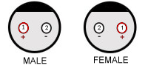
Round Waterproof connectors:
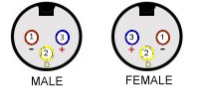

 | +5 Volts | Ground | Data
3-Pin | Blue | Brown | Yellow/Green
 | 3 | 1 | 2
2-Pin | Red | Black
 | 2 | 1
Barrel | Tip | Sleeve
 | Red Stripe | Silver - No Stripe
Wire | Smooth | Ribbed
Pixel | Red | White | Green

Pixels: Data In – Chip Side
Data Out – PCB Side

